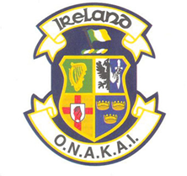
O.N.A.K.A.I.
Minor Athlete Anti-Doping Consent Form
Anti-doping testing may occur at any EKF, WKF event or Youth Olympic Games

All athletes under the age of 18 years (minors) require this form to be completed by a parent or guardian in the event that they may be selected for testing at a Cadet, Junior and U21 EKF or WKF event or at a Junior Olympic Games.

I _____________________ , parent/guardian of ____________________ give my consent to my child being tested at a WKF sanctioned event by authorised personnel.

Name________________________________________________

Club_________________________________________________

Date of Birth_____________________________

Parent / Guardian_______________________________________

Signature__________________________________________ Date_________
Travelling Coach
Signature__________________________________________ Date_________
National Coach (Kata/Kumite)
Signature__________________________________________ Date_________

